**DATA CLEANING**

UPDATE [BlinkIT Grocery Data (1)]

SET [Item_Fat_Content] = 'Low Fat'

WHERE [Item_Fat_Content] IN ('LF', 'low fat');

UPDATE [BlinkIT Grocery Data (1)]

SET [Item_Fat_Content] = 'Regular'

WHERE [Item_Fat_Content] IN ('Reg');

**1)TOTAL SALES**

SELECT CAST(SUM(Sales)/1000000 AS decimal(10,2)) as "Total sales in Millions" from [BlinkIT Grocery Data (1)]

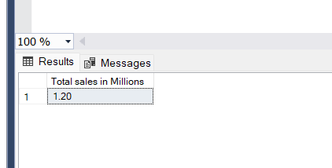

**2)AVERAGE SALES**

SELECT CAST(AVG(SALES) AS DECIMAL(10,2)) AS "AVG SALES" FROM [BlinkIT Grocery Data (1)]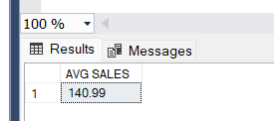

**3)COUNT OF TOTAL ITEMS SOLD**

SELECT COUNT(*) AS NO_OF_SOLD_ITEMS FROM [BlinkIT Grocery Data (1)]

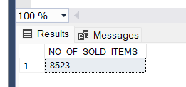

**4)AVERAGE RATING**

SELECT CAST(AVG(RATING) AS DECIMAL(10,2)) AS "AVG RATING" FROM [BlinkIT Grocery Data (1)]

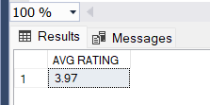

**5)TOTAL SALES DEPENDING ON ITEM FAT CONTENT**

SELECT Item_Fat_Content,CAST(SUM(Sales)/1000000 AS decimal(10,2)) as "Total sales in Millions" from [BlinkIT Grocery Data (1)]

GROUP BY Item_Fat_Content

ORDER BY [Total sales in Millions] DESC

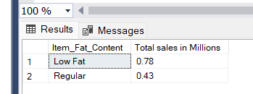

**6)OTHER METRICS(LIKE AVG SALES,AVG RATING) VARYING WITH FAT CONTENT**

SELECT Item_Fat_Content, CAST(SUM(Sales)/1000000 AS decimal(10,2)) as "Total sales in Millions",

CAST(AVG(SALES) AS DECIMAL(10,2)) AS "AVG SALES" ,

COUNT(*) AS NO_OF_SOLD_ITEMS,

CAST(AVG(RATING) AS DECIMAL(10,2)) AS "AVG RATING" FROM [BlinkIT Grocery Data (1)]

GROUP BY Item_Fat_Content

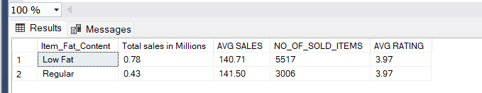

**7)TOTAL SALES AND OTHER METRICS DEPENDING ON ITEM TYPE**

SELECT Item_Type, CAST(SUM(Sales)/1000 AS decimal(10,2)) as "Total sales in Thousands",

CAST(AVG(SALES) AS DECIMAL(10,2)) AS "AVG SALES" ,

COUNT(*) AS NO_OF_SOLD_ITEMS,

CAST(AVG(RATING) AS DECIMAL(10,2)) AS "AVG RATING" FROM [BlinkIT Grocery Data (1)]

GROUP BY Item_Type

ORDER BY [Total sales in Thousands] DESC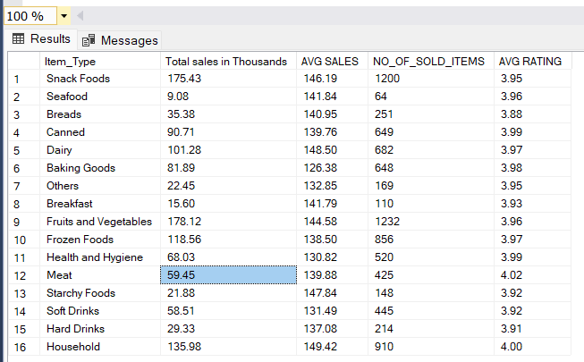

**8)TOTAL SALES ACROSS DIFFERENT OUTLET LOCATION TYPE SEGMENTED BY FAT CONTENT**

SELECT

Outlet_Location_Type,

ISNULL([Low Fat], 0) AS "Low Fat",

ISNULL([Regular], 0) AS "Regular"

FROM (

SELECT

Outlet_Location_Type,

Item_Fat_Content,

CAST(SUM(SALES)/1000 AS DECIMAL(10,2)) AS TOTAL_SALES_IN_THOUSANDS

FROM

[BlinkIT Grocery Data (1)]

GROUP BY

Item_Fat_Content, Outlet_Location_Type

) AS SourceTable

PIVOT (

MAX(TOTAL_SALES_IN_THOUSANDS)

FOR Item_Fat_Content IN ([Low Fat], [Regular])

) AS PivotTable

ORDER BY

Outlet_Location_Type;

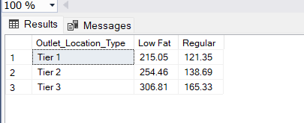

**9)TOTAL SALES ACCORDING TO OUTLET ESTABLISHMENT YEAR**

SELECT

Outlet_Establishment_Year,

CAST(SUM(SALES)/1000 AS DECIMAL(10,2)) AS TOTAL_SALES_IN_THOUSANDS

FROM

[BlinkIT Grocery Data (1)]

GROUP BY

Outlet_Establishment_Year

ORDER BY TOTAL_SALES_IN_THOUSANDS DESC

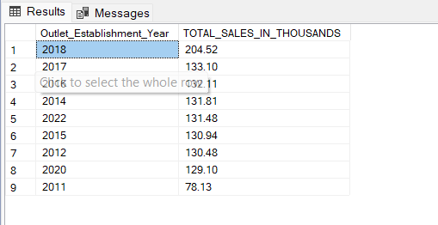

**10)WITH OTHER METRICS INCLUDED VARYING WITH OUTLET ESTABLISHMENT YEAR**

SELECT

Outlet_Establishment_Year,

CAST(SUM(SALES)/1000 AS DECIMAL(10,2)) AS TOTAL_SALES_IN_THOUSANDS,

CAST(AVG(SALES) AS DECIMAL(10,2)) AS "AVG SALES",

COUNT(*) AS NO_OF_SOLD_ITEMS,

CAST(AVG(RATING) AS DECIMAL(10,2)) AS "AVG RATING"

FROM

[BlinkIT Grocery Data (1)]

GROUP BY

Outlet_Establishment_Year

ORDER BY Outlet_Establishment_Year

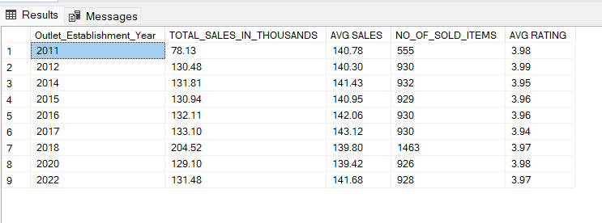

**11)PERCENTAGE OF SALES WITH VARYING OUTLET SIZE**

SELECT Outlet_Size,

CAST(SUM(SALES)/1000 AS DECIMAL(10,2)) AS TOTAL_SALES_IN_THOUSAND,

CAST((SUM(SALES)*100/SUM(SUM(SALES)) OVER()) AS DECIMAL(10,2)) AS SALES_PERCENTAGE

FROM [BlinkIT Grocery Data (1)]

GROUP BY Outlet_size

ORDER BY TOTAL_SALES_IN_THOUSAND DESC

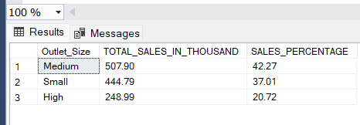

**12)SALES AND OTHER METRICS BASED ON OUTLET LOCATION**

SELECT

Outlet_Location_Type,

CAST(SUM(SALES)/1000 AS DECIMAL(10,2)) AS TOTAL_SALES_IN_THOUSANDS,

CAST(AVG(SALES) AS DECIMAL(10,2)) AS "AVG SALES",

COUNT(*) AS NO_OF_SOLD_ITEMS,

CAST(AVG(RATING) AS DECIMAL(10,2)) AS "AVG RATING"

FROM

[BlinkIT Grocery Data (1)]

GROUP BY

Outlet_Location_Type

ORDER BY TOTAL_SALES_IN_THOUSANDS

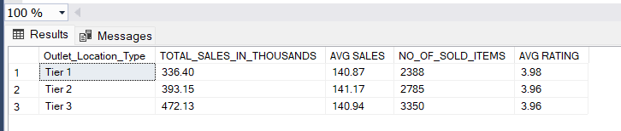

**13)ALL METRICS ACCORDING TO OUTLET TYPE**

SELECT

Outlet_Type,

CAST(SUM(SALES)/1000 AS DECIMAL(10,2)) AS TOTAL_SALES_IN_THOUSANDS,

CAST(AVG(SALES) AS DECIMAL(10,2)) AS "AVG SALES",

COUNT(*) AS NO_OF_SOLD_ITEMS,

CAST(AVG(RATING) AS DECIMAL(10,2)) AS "AVG RATING"

FROM

[BlinkIT Grocery Data (1)]

GROUP BY

Outlet_Type

ORDER BY TOTAL_SALES_IN_THOUSANDS

